Table of Contents
Table of Contents 1
List of Tables 2
List of Figures 3
Chapter Two: Literature Review 4
1.1 Conceptualising the Native Speaker 4
1.1.1 Native Speaker in Linguistics and Second Language Acquisition 4
1.1.2 Native Speaker in Sociolinguistics 4
1.2 This the second main section of chapter 2 5
1.2.1 This is the first subsection of the second main section 5
1.3 Conclusion 6
References 6

List of Tables
Table 1. Title goes here 10

List of Figures
Figure 1. Title goes here 9

Chapter Two: Literature Review
Introduction to the chapter:
- 3-4 paragraphs
- Introduce the main topics to be presented
- Present the organisation of the entire chapter
Example:

This chapter reviews the literature connected to the influence of the ideology of native speakerism on the ELT profession. Native speakerism is a term coined and described by Holliday (2005, 2006), and later reconceptualised by Houghton and Rivers (2013a), which refers to a widespread ideology in ELT that discriminates against teachers based on their perceived belonging to a first language (L1) group, usually manifesting itself in privileging ‘native speakers’ as superior models of language, embodiments of a superior Western methodology, and thus ultimately as better teachers. Although native speakerism only started to be described and studied recently, its roots are much deeper and go beyond the domain of ELT.
Just as other negative ideologies such as racism or sexism, native speakerism is buttressed by powerful discourses which normalise and justify it, leading to the maintenance of discriminatory social practices. Some of the discourses supporting native speakerism can be traced back to how the NS has been conceptualised in theoretical, applied and educational linguistics, which has viewed the NS as an infallible linguistic ideal all learners should aspire to. The ideology is also evident in Second Language Acquisition (SLA) research, which frequently used an idealised NS as the benchmark to which learners’ progress should be compared.
These ideas have also percolated to ELT, on which now native speakerism exerts a strong and manifold influence. For example, the ideology is evident in the ‘native speaker’ fallacy (Phillipson, 1992), or the belief that any ‘native speaker’ is a priori a better teacher of English. This often leads to discriminatory recruitment policies, whereby around three quarters of all ELT jobs are for ‘native speakers’ only (Kiczkowiak, 2015; Mahboob & Golden, 2013; Selvi, 2010).
However, these discourses ignore the fact that English has now become a global language of international communication. As a result, SE cannot be seen any more as the unique standard norm for teaching and learning English. The emergence of ELF and English as an International Language (EIL) research have led scholars to question native speakerism. While some researchers still object to this pluricentric view of the English language, as do some students and teachers; it seems that this research does offer a possibility to make both ELT and SLA reconsider how and which English is to be taught, as well as the role of ‘native’ and ‘non-native speakers’ in ELT.
Another strand of research which has tried to question the privileged position of ‘native speakers’ teachers within ELT focused on identifying the strengths and weaknesses ‘native’ and ‘non-native speakers’ have as teachers. While partly successful in proving that ‘non-native speakers’ could also teach English well, it has led to creating even more stereotypes about the two groups. These stereotypes are often visible in the way recruiters and students view ‘native’ and ‘non-native speaker’ teachers. In contrast, it seems that a possible way out from the native speakerist ideology is a focus on the qualities of effective teachers in general, regardless of their L1.
However, before the literature review of the impact of the ideology of native speakerism on ELT is undertaken, it is essential to first explore and attempt to define the key term that lies at the very core of native speakerism and of this project, and which has already been used in this introduction; that is, ‘native’ and ‘non-native speaker’. This is important as the discourses which support native speakerism, and which are discussed in the following sections of this chapter, do not problematize the two concepts, assuming that they are well-defined, objective and value-free.

Conceptualising the Native Speaker
This is the introduction to the first big section of the literature review:
- 1-2 paragraphs
- Introduce the main topics to be presented
- Present the organisation of the section
Example:

As pointed out above, the literature review first focuses on what it means to be a ‘native speaker’ of a particular language, reviewing different definitions which have been proposed since Bloomfield introduced the term to modern linguistics. This initial exploration is also important because as Braine (1999c) and Faez (2011) point out, the terms ‘native’ and ‘non-native speaker’ have been and still are widely used in theoretical and applied linguistics, as well as SLA and ELT research and practice despite the fact that no satisfactory and conclusive definition of the two terms has been proposed. As a result, the labels ‘native’ and ‘non-native speaker’ are often employed arbitrarily, and can be used to discriminate against those who are perceived as not belonging to the ‘native speaker’ group.
First, the concept of the ‘native speaker’ and how it has been utilised and defined in applied linguistics is presented. Next, these definitions are criticised from the sociolinguistic standpoint, showing that being a ‘native speaker’ is not merely a linguistically, but rather very much a socially determined trait. This has led many researchers to propose several alternative terms, none of which seem entirely satisfactory, however. Afterwards, the connection between racial discourse behind labelling individuals as ‘native speakers’ is outlined, highlighting that very often being a ‘native speaker’ of English is associated with being white and Western-looking. Finally, the chapter ends by critiquing the post-positivist approach which views the ‘native speaker’ as an innate, fixed, definable and objective trait, and by discussing the dilemma of which (if any) labels should be used in the rest of this work.

Native Speaker in Linguistics and Second Language Acquisition
This is the first subsection

Native Speaker in Sociolinguistics
This is the second subsection
Thus, as Nayar (1998, quoted in Jenkins, 2015, p. 122) put it, ELT has created, propagated and maintained:
This is a block quote.
This is very much evident in ELT recruitment practices, which is the last discourse used to legitimise native speakerism that will be presented here.
As one of the participants observed:
Quote from a participant

ELT Recruitment Policies and Native Speakerism
This is the first subsection of the second subsection
As can be seen in Figure 1 below, an alternative hierarchy which prioritises English for international use, whether used by ‘native speakers’ or ‘non-native speakers’ is proposed:
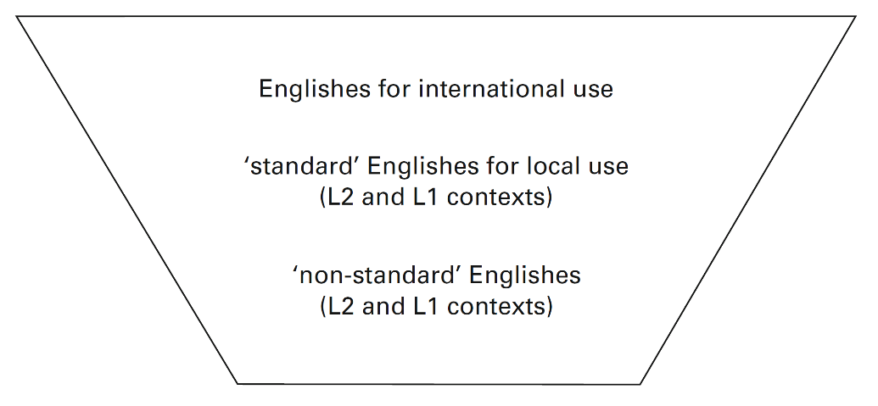
Figure 1. Title goes here

As a result,
In addition to the background data already presented, the teacher respondents were also asked about the highest teaching qualification they held. These data are shown in Table 2 below.
As discussed previously (see 2.1.2)

Table 1. Title goes here
Qualification | No | [%]
CELTA or Trinity Cert | 13 | 54.2
BA in TESOL or related field | 3 | 12.5
DELTA or Trinity Diploma | 3 | 12.5
MA in TESOL or related field | 5 | 20.8
PhD in TESOL or related field | 0 | 0

End the last subsection with a link to the following subsection, e.g. One consequence of this is X. This will be discussed in the following section.

This the second main section of chapter 2
This is the introduction to the second main section of the literature review:
- 1-2 paragraphs
- Introduce the main topics to be presented
- Present the organisation of the section

This is the first subsection of the second main section
This is the first subsection

Conclusion
In here you conclude the entire chapter:
- 3-4 paragraphs
- Outline the main topics presented and the key-take away messages
- Provide a link to the following chapter

Example:
This chapter has illustrated the complex and varied influence that the ideology of native speakerism has had on ELT. Similarly to other ideologies, native speakerism is buttressed by powerful and widespread discourses which make it seem reasonable and scientifically justifiable. First, the ideology is evident in how the terms ‘native’ and a ‘non-native speaker’ have been used in SLA and ELT, creating an idealised image of a linguistically infallible ‘native speaker’. Other discourses that lead to an entrenchment and spread of native speakerism can also be seen in SLA research, a substantial amount of which has used the ‘native speaker’ as an unquestionable benchmark to which all second language acquisition should be compared. In ELT, this ideology is reflected in a widespread belief that ‘native speakers’ are better teachers of English, which leads to discriminatory recruitment policies.
More recently, ELF research has proposed an alternative, more pluricentric view of the English language, which not only acknowledges but also embraces its diversity and that of its users. This research, nevertheless, has met with some scepticism and resistance from both a part of the research community, as well as some students and teachers. Despite this criticism, ELF can be seen as an important breakthrough and a possible way forward beyond the corrosive ideology of native speakerism. Similarly, abandoning research focused on identifying distinct strengths and weaknesses of ‘native’ and ‘non-native speaker’ teachers in favour of investigating what makes an effective language teacher, regardless of their L1, also seems to offer a solution to tackling native speakerism.
In the following chapter, the study proper is discussed. This study aims to investigate native speakerism in language schools in Poland by researching teachers’, students’ and recruiters’ perceptions of some of the main discourses that support the ideology, which have been discussed thus far. More specifically, this project aims to see how the three cohorts understand the concept of ‘native’ and ‘non-native speakers’, and whether the discourse of SE and the ‘native speaker’ fallacy are present in how these two groups of teachers are perceived. Finally, one of the aims of this research is also to explore which skills students, teachers and recruiters value highly in teachers of English. These objectives are presented in more detail in the following chapter.

References
Jenkins, J. (2015). Global Englishes: A resource book for students (3rd ed.). Routledge.

