Table of Contents
Chapter 1 Literature review 2
1.1 First subsection 2
1.1.1 Third level subsection 2
1.1.2 Another third level subsection 2
1.2 Second subsection 2

List of Figures
Figure 1. Title goes here 3

Chapter 1 Literature review
This chapter will

1.1 First subsection
As pointed out above, the literature review will first focus on

1.1.1 Third level subsection

1.1.2 Another third level subsection
While the

1.2 Second subsection
The discussion thus far shows that
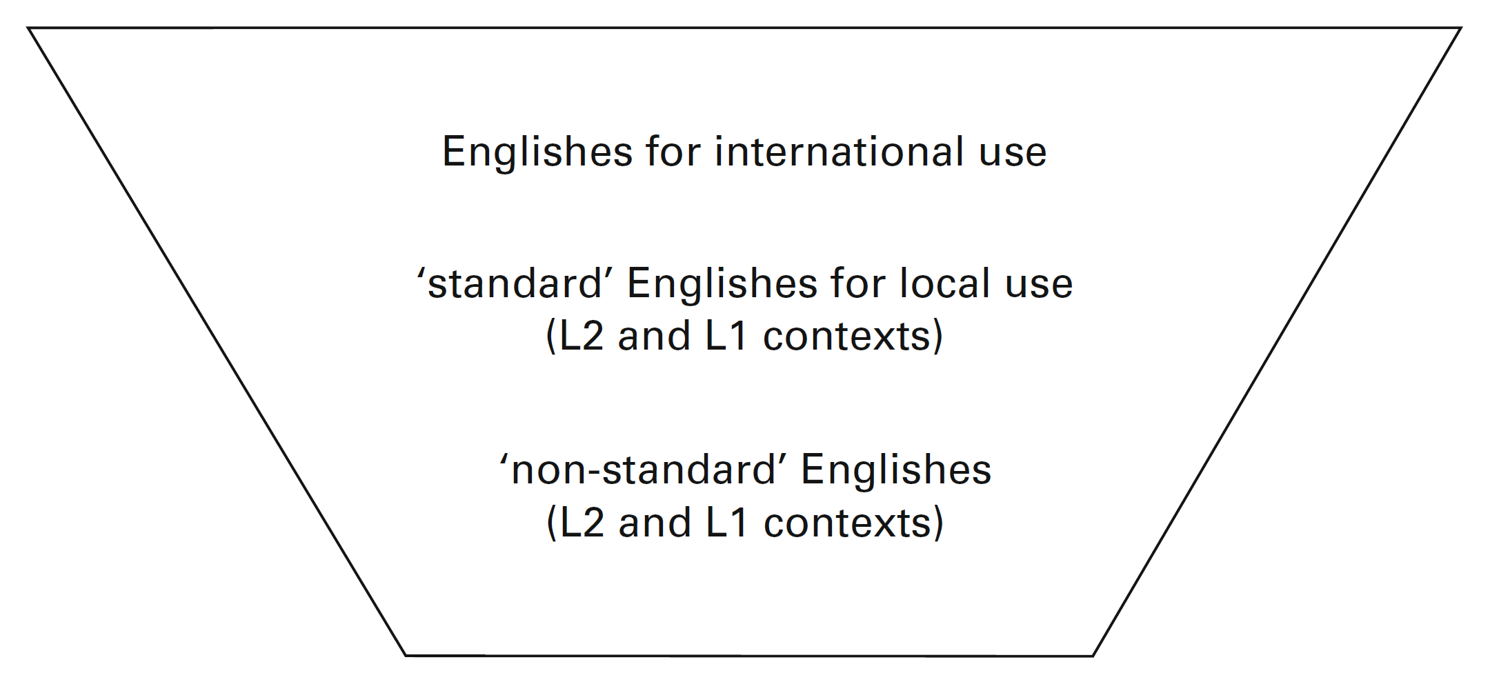
Figure 1. Title goes here

